Mini Project - 1

|  |  |
| --- | --- |
| **Student Name/ID Number:** | Agung Yuda Pratama / BDSE-0922-076 |
| **Unit Number and Title:** | ACWD Module 4 – Database Design & Implementation |
| **Academic Year:** | 2023 |
| **Unit Assessor:** |  |
| **Project Title:** | Database Design for Community Portal |
| **Issue Date:** |  |
| **Submission Date:** |  |
| **Internal Verifier Name:** |  |
| **Date:** | 16 January 2023 |

|  |
| --- |
| **Learner declaration** |
| I certify that the work submitted for this assignment is my own and research sources are fully acknowledged.  Student signature: Date: 16 January 2023 |

|  |
| --- |
| **Purpose of this project** |
| **Purpose of this project**  To demonstrate your capabilities in the following areas:   * Design a Database for Community Portal |
| **Submission Format** |
| 1. Description of Entities in the database 2. Screen capture of the ER Diagram 3. Screen capture of Data 4. Screen capture of Normalized Database Design 5. Documentation of Relationships |
| **Project Brief & Guidance** |
| **Scenario:**  **Refer to the Project Scenario for the Module Project**  You have been approached by ‘ABC Jobs Pte Ltd’ as a website developer to develop a community portal for Software Developers. The project will be carried over through Module 3, Module 4, Module 5 and Capstone project. For this module the scope is to Design, Develop, Implement & Document Apache Struts Framework Website.  The Scope of the Project is to design a Community Portal Similar to Linkedin.com. Users will be able to register in the portal using the Registration Page. Users of the portal can search for other users using various parameters such as First Name, Last Name, Company Name, City & Country. Users will be able to view the Public Profile of users after searching them. The portal allow users to login, request for forgotten password and Update their profile information  The scope of the mini project is to design the database.  **The overview of the project is as below**  There are 2 types of users in this Community portal. They are   1. Software Programmer 2. Administrator   **Software Programmer should be able to perform following functions in the portal** |

|  |
| --- |
| 1. Allow the programmers to register in the portal, show a thank you page & send a registration confirmation email. 2. Search & Find Other Programmers after login and view their profile. 3. Provide Login Page 4. Provide password retrieval functionality. 5. Update their Profile after logging in.   Following Functionality is part of Database Design & Will be enhanced as features as required in the Capstone Project, Depending on time availability.   1. Send Messages to Each Other on the Portal 2. Create Threads & Post Replies to a Thread 3. Post Job Opportunities in the Portal   **Administrator should be able to perform following functions in the portal**   1. Administer user data. 2. Send bulk email inviting programmers to register on the community portal   **The portal consist of the following Key pages (For Reference)**   1. Community Portal Home Page 2. Registration Page 3. Registration Confirmation Page 4. Update Profile Page 5. Search Users Page 6. List Search Results 7. Public Profile Page 8. Registration Confirmation Email 9. Login Page 10. Forget Password Page 11. Design the Forget Password Confirmation Page   Following Functionality is part of Database Design and will not be part of development & Will be enhanced as features are required in the Capstone Project, Depending on time availability.   1. Send Messages 2. Read Messages 3. Post in Message Board 4. List Message Board 5. Read A Thread 6. Post Job Opportunities 7. List Job Opportunities & Responses   **The scope of this assignment**  The scope is to design the community portal database.   * 1. Identify the Entities in the Community Portal Database   2. Create ER Diagram for the Community Portal Database |

1. Create Sample data for all tables in the community portal (At least 3 tables)
2. Normalize the complete database to 3rd normal form (Provide screen capture of the normalization done)
3. Identify the relationships in tables & document them

**The Solutions**

1. **The Entity that The Writer needs to do this Assignment 1 is**

|  |  |  |
| --- | --- | --- |
| **Entity** | **Description** | **Page/Function** |
| **User** | It contains information about registering and login | Registration and Login Page |
| **Administrator** | Admin can administer users and send bulk email | Administrator Page |
| **Email** | To store the e-mail information of each user registered in the system. | Registration and Login Page |
| **Job** | It provides details about the user's job prospects. | Job Page |
| **Messages** | Users can send and receive messages | Messages Page |

1. **This is the ER Diagram for Assignment 1**

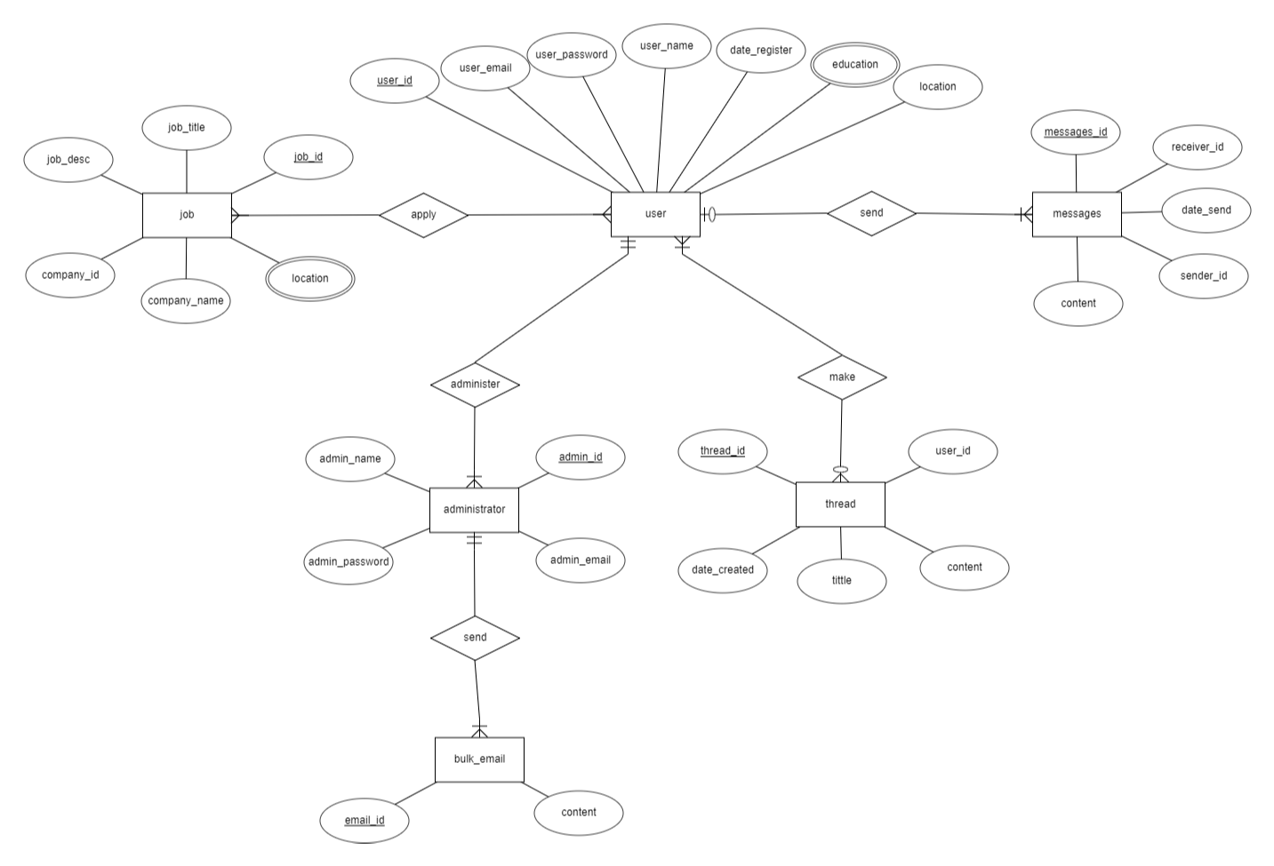

1. **This is sample data for Assignment 1**
2. **User Table**

|  |  |  |  |  |  |  |
| --- | --- | --- | --- | --- | --- | --- |
| user_id | user_email | user_password | user_name | date_register | education | location |
| 1 | user1@example.com | 12345 | Richard Smith | 03/12/2022 | Bachelor's, Master’s | Illinois |
| 2 | [user2@example.com](mailto:user2@example.com) | Qwerty | Jane Doe | 21/10/2022 | Master’s, | Los Angeles |
| 3 | [user3@example.com](mailto:user3@example.com) | Abc123 | Michael Davis | 01/02/2022 | Ph.D | New York |
| 4 | user4@example.com | Mypass | David Lee | 07/01/2023 | High School | Los Angeles |
| 5 | user5@example.com | Pass321 | Jalen Green | 05/01/2023 | Bachelor’s, Master’s | Illinois |

1. **Job Table**

|  |  |  |  |  |  |
| --- | --- | --- | --- | --- | --- |
| job_id | job_title | job_desc | company_id | company_name | location |
| 1 | Software Engineer | Make and develop software | 1001 | XYZ Inc. | San Francisco, Memphis |
| 2 | Data Analyst | Do data analysis and serve the report | 1002 | ABC Corp. | Chicago |
| 3 | Cyber Security | Defend some company or website from hackers and virus | 1003 | DEFF Inc. | Ohio, Washington |
| 4 | AI | Make AI for easier human life | 1004 | Intelligence Corp. | Seattle |

1. **Administrator Table**

|  |  |  |  |
| --- | --- | --- | --- |
| admin_id | admin_email | admin_password | admin_name |
| 1 | [admin1@example.com](mailto:admin1@example.com) | Passadmin1 | Jonatahn Berg |
| 2 | [admin2@example.com](mailto:admin2@example.com) | Passadmin2 | Clara Fox |
| 3 | [admin3@example.com](mailto:admin3@example.com) | Passadmin3 | Laura Love |
| 4 | [admin4@example.com](mailto:admin4@example.com) | Passadmin4 | Michael Brown |

1. **Normalize database to:**
2. **1NF**

**User Table**

|  |  |  |  |  |
| --- | --- | --- | --- | --- |
| user_id | user_email | user_password | user_name | date_register |
| 1 | user1@example.com | 12345 | Richard Smith | 03/12/2022 |
| 1 | user1@example.com | 12345 | Richard Smith | 03/12/2022 |
| 2 | [user2@example.com](mailto:user2@example.com) | Qwerty | Jane Doe | 21/10/2022 |
| 3 | [user3@example.com](mailto:user3@example.com) | Abc123 | Michael Davis | 01/02/2022 |
| 4 | user4@example.com | Mypass | David Lee | 07/01/2023 |
| 5 | user5@example.com | Pass321 | Jalen Green | 05/01/2023 |
| 5 | user5@example.com | Pass321 | Jalen Green | 05/01/2023 |

**Job Table**

|  |  |  |  |  |  |  |
| --- | --- | --- | --- | --- | --- | --- |
| job_id | job_title | job_desc | company_id | | company_name | location |
| 1 | Software Engineer | Make and develop software | 1001 | XYZ Inc. | | San Francisco |
| 1 | Software Engineer | Make and develop software | 1001 | XYZ Inc. | | Memphis |
| 2 | Data Analyst | Do data analysis and serve the report | 1002 | ABC Corp. | | Chicago |
| 3 | Cyber Security | Defend some company or website from hacker and virus | 1003 | DEFF Inc. | | Ohio |
| 3 | Cyber Security | Defend some company or website from hacker and virus | 1003 | DEFF Inc. | | Washington |
| 4 | AI | Make AI for easier human life | 1004 | Intelligence Corp. | | Seattle |

**Administrator Table**

|  |  |  |  |
| --- | --- | --- | --- |
| admin_id | admin_email | admin_password | admin_name |
| 1 | [admin1@example.com](mailto:admin1@example.com) | Passadmin1 | Jonatahn Berg |
| 2 | [admin2@example.com](mailto:admin2@example.com) | Passadmin2 | Clara Fox |
| 3 | [admin3@example.com](mailto:admin3@example.com) | Passadmin3 | Laura Love |
| 4 | [admin4@example.com](mailto:admin4@example.com) | Passadmin4 | Michael Brown |

The table is already in 1NF because it has a primary key (admin_id) and no repeating data groups.

1. **2NF**

**User Table**

**Table 1**

|  |  |  |  |
| --- | --- | --- | --- |
| user_id | user_email | user_password | user_name |
| 1 | user1@example.com | 12345 | Richard Smith |
| 1 | user1@example.com | 12345 | Richard Smith |
| 2 | [user2@example.com](mailto:user2@example.com) | Qwerty | Jane Doe |
| 3 | [user3@example.com](mailto:user3@example.com) | Abc123 | Michael Davis |
| 4 | user4@example.com | Mypass | David Lee |
| 5 | user5@example.com | Pass321 | Jalen Green |
| 5 | user5@example.com | Pass321 | Jalen Green |

**Table 2**

|  |  |
| --- | --- |
| user_id | date_register |
| 1 | 03/12/2022 |
| 1 | 03/12/2022 |
| 2 | 21/10/2022 |
| 3 | 01/02/2022 |
| 4 | 07/01/2023 |
| 5 | 05/01/2023 |
| 5 | 05/01/2023 |

**Table 3**

|  |  |  |
| --- | --- | --- |
| user_id | education | location |
| 1 | Bachelor's | Illinois |
| 1 | Master’s | Illinois |
| 2 | Master’s | Los Angeles |
| 3 | Ph.D | New York |
| 4 | High School | Los Angeles |
| 5 | Bachelor’s | Illinois |
| 5 | Master’s | Illinois |

**Job Table**

**Table 1**

|  |  |  |
| --- | --- | --- |
| job_id | job_title | job_desc |
| 1 | Software Engineer | Make and develop software |
| 1 | Software Engineer | Make and develop software |
| 2 | Data Analyst | Do data analysis and serve the report |
| 3 | Cyber Security | Defend some company or website from hacker and virus |
| 3 | Cyber Security | Defend some company or website from hacker and virus |
| 4 | AI | Make AI for easier human life |

**Table 2**

|  |  |  |  |
| --- | --- | --- | --- |
| company_id | | company_name | location |
| 1001 | XYZ Inc. | | San Francisco |
| 1001 | XYZ Inc. | | Memphis |
| 1002 | ABC Corp. | | Chicago |
| 1003 | DEFF Inc. | | Ohio |
| 1003 | DEFF Inc. | | Washington |
| 1004 | Intelligence Corp. | | Seattle |

**Administrator Table**

**Table 1**

|  |  |
| --- | --- |
| admin_id | admin_name |
| 1 | Jonatahn Berg |
| 2 | Clara Fox |
| 3 | Laura Love |
| 4 | Michael Brown |

**Table 2**

|  |  |  |
| --- | --- | --- |
| admin_id | admin_email | admin_password |
| 1 | [admin1@example.com](mailto:admin1@example.com) | Passadmin1 |
| 2 | [admin2@example.com](mailto:admin2@example.com) | Passadmin2 |
| 3 | [admin3@example.com](mailto:admin3@example.com) | Passadmin3 |
| 4 | [admin4@example.com](mailto:admin4@example.com) | Passadmin4 |

1. **3NF**

**User Table**

**Table 1**

|  |  |  |
| --- | --- | --- |
| user_id | user_email | user_password |
| 1 | user1@example.com | 12345 |
| 1 | user1@example.com | 12345 |
| 2 | [user2@example.com](mailto:user2@example.com) | Qwerty |
| 3 | [user3@example.com](mailto:user3@example.com) | Abc123 |
| 4 | user4@example.com | Mypass |
| 5 | user5@example.com | Pass321 |
| 5 | user5@example.com | Pass321 |

**Table 2**

|  |  |
| --- | --- |
| user_id | user_name |
| 1 | Richard Smith |
| 1 | Richard Smith |
| 2 | Jane Doe |
| 3 | Michael Davis |
| 4 | David Lee |
| 5 | Jalen Green |
| 5 | Jalen Green |

**Table 3**

|  |  |
| --- | --- |
| user_id | date_register |
| 1 | 03/12/2022 |
| 1 | 03/12/2022 |
| 2 | 21/10/2022 |
| 3 | 01/02/2022 |
| 4 | 07/01/2023 |
| 5 | 05/01/2023 |
| 5 | 05/01/2023 |

**Table 4**

|  |  |
| --- | --- |
| user_id | education |
| 1 | Bachelor's |
| 1 | Master’s |
| 2 | Master’s |
| 3 | Ph.D |
| 4 | High School |
| 5 | Bachelor’s |
| 5 | Master’s |

**Table 5**

|  |  |
| --- | --- |
| user_id | location |
| 1 | Illinois |
| 1 | Illinois |
| 2 | Los Angeles |
| 3 | New York |
| 4 | Los Angeles |
| 5 | Illinois |
| 5 | Illinois |

In 3NF, each column must have no indirect dependencies on the primary key. For example, in 3NF tables, education and location have no indirect dependencies on user_id, so they can be separated into separate tables.

**Job Table**

The table above is 3NF compliant because there are no attributes that are not related to the primary key (job_id) indirectly (transitive dependencies). In the table above, there are no unnecessary attributes. So the table above is in accordance with 3NF.

**Administrator Table**

There is no transitive dependency in this table, so this table is already in 3NF.

1. **This is Logical Database Design and Relation**

